Name: _______________________ Class: __________ Date: _______
Instructions: Write answers in the right-hand column. Score: ___________ / 53 marks
Section A— Multiple choice (10 marks)

 | Describe a decomposer organism.  A An animal that eats another animal  B A plant that loses its leaves in winter  C An organism that breaks down organic matter so it is recycled  D An animal that uses sound as its main method of communication | C | 1
 | Identify the biotic factor in an organism’s environment that can affect its survival.  A The amount of water available  B The quality of the air  C Events such as fire and flood  D Competitors for living space | D | 1
 | There are consequences of the introduction of the European fox into Australia in the 1860s. Select the consequence that is a benefit for the natural environment.  A It attacks lambs and chickens.  B It eats a wide variety of native animals.  C It eats rabbits—another introduced species.  D It provided sport for fox hunters. | C | 1
 | Deduce which of these human activities would have a negative impact on a natural environment.  A Clearing forests and replacing them with exotic trees  B Removing grazing cattle from a natural woodland  C Replanting eucalypt trees  D Reintroducing koalas into eucalypt forests | A | 1
 | Deduce which of these human activities has a positive effect on food webs.  A Opening up an area of bushland for recreational activities  B Removing introduced predators from an area  C Overfishing particular fish species causing a decline in numbers  D Introducing exotic species, such as rabbits and foxes | B | 1
 | Recall the ultimate source of energy for all the organisms in a food web.  A Soil for providing essential minerals  B Water to prevent dehydration  C Green plants for photosynthesis  D The Sun for providing light | D | 1
 | Define an organism’s habitat.  A The place where the organism lives  B The place where the organism is at a point in time  C The place where all the abiotic factors are suited to the organism’s survival  D A place where the organism hunts for food | A | 1
 | Define adaptations.  A Living factors that influence where an organism lives  B Non-living factors that influence where an organism lives  C Features of an organism that help it survive in its environment  D Organisms that inhabit a specific region | C | 1
 | Identify the term that is defined by the following: ‘an interaction between organisms in which both the organisms benefit from the relationship and neither is harmed’.  A Parasitism  B Commensalism  C Mutualism  D Competition | C | 1
 | Identify the term that is defined by the following: ‘an interaction between two organisms in which one of them benefits but the other one is not affected’.  A Competition  B Parasitism  C Mutualism  D Commensalism | D | 1

Section B— Short answer (28 marks)

- ` | The diagram represents a food web in a freshwater lake.  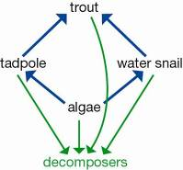  a Deduce the effect on the population of water snails if the trout were fished out of the lake by fishing enthusiasts.  b Explain your answer. | a The water snail population would increase.  b Once the trout were removed from this food web, there would be no predators left to eat the water snails. | 2
 | Since European settlement in Australia, more than 50% of eucalypt forests and about 75% of rainforests have been removed. Explain how increasing the native vegetation cover in Australia by planting more native trees and shrubs could benefit native plants and animals. | The native trees and shrubs would grow, flower and produce seeds. These seeds would germinate and grow, increasing the number of those particular plants. Native plants provide food and shelter for native animals. When the animals’ needs are met by their habitat, they are more likely to reproduce successfully, increasing their own population. | 3
 | Deduce whether each of the statements listed are true or false.  a The wind is a part of an organism’s environment.  b Parasitism is an interaction in which one type of organism lives on or in another type of organism and usually causes it harm.  c The forest that includes a tree in which a spider lives is regarded as the spider’s habitat.  d Endangered species are close to extinction and very small numbers remain.  e Sustainable ecosystems are ecosystems able to provide for the needs of the organisms living there for a short period of time. | a true  b true  c false  d true  e false | 5
 | Describe these terms by matching them with the correct definition: habitat, biosphere, ecosystem, environment.  a A particular area in which a group of organisms live, interacting with one another and with their non-living surroundings.  b The place where an animal or plant lives at a particular time.  c A combination of all of the living and non-living factors that an organism is subject to in the place where it lives.  d The place where all life exists. It consists of the Earth and its atmosphere. | a ecosystem  b habitat  c environment  d biosphere | 4
 | Use your knowledge and the food chain below to answer the following questions.  Grass → grasshopper → frog → snake → kookaburra  a Classify the organisms in this food chain as producers and consumers.  b Explain why producers and consumers are so named. | a Producers: grass  Consumers: grasshopper, frog, snake, kookaburra  b Producers are the organisms that use the Sun’s energy to produce or make energy-rich compounds. Consumers are the organisms that consume or eat other organisms, either producers or other consumers. | 2
 | Study the diagram shown, which represents a food web in a freshwater creek.  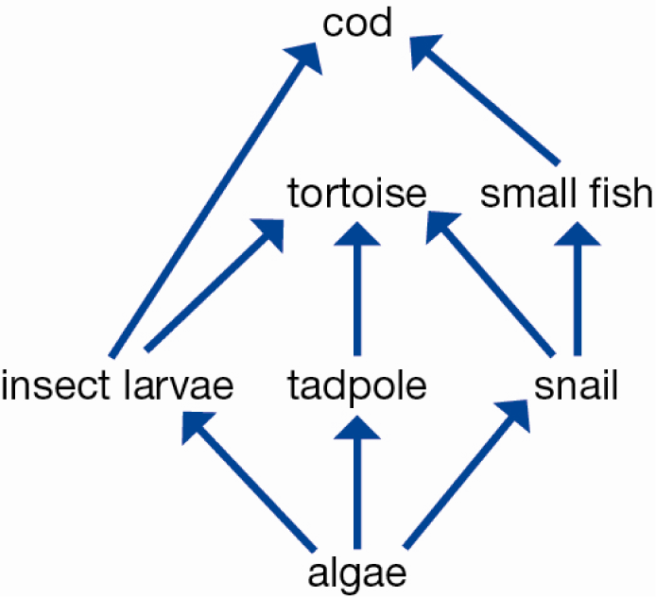  a Explain what the arrow between two organisms means.  b Identify the very important group of organisms that has not been included in this food web.  c Explain the role of this group of organisms.  d Identify and record two different food chains that include the tortoise.  e Explain why this community could not survive without the algae. | a The arrow between two organisms represents the direction of energy flow. A → B implies that B consumes A and obtains energy and matter from it.  b The decomposers have been left out of this food web.  c They feed on the dead remains of plants and animals and their wastes. They are important because they break this matter down and return many useful substances to the environment.  d algae → tadpole → tortoise → cod  algae → insect larvae → tortoise → cod  algae → snail → tortoise → cod  e Algae are the only producer organisms in the community, and therefore all the consumers rely directly or indirectly on them for food. | 5
 | The spinifex hopping mouse shown in the photo is native to the central Australian desert. It is active at night and shelters in a complex burrow system during the day.  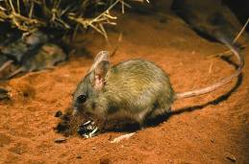  Describe two characteristics of the organism that are adaptations to living in the hot desert and being active at night. | Any feature taken from the description or photograph, for example: sandy colour provides camouflage against desert soils; large eyes help it to see in the dark when it is most active; burrowing habit provides protection against predators and the heat; large ears help it to hear predators and to lose body heat. | 2
 | These three images are of birds that eat very different food.  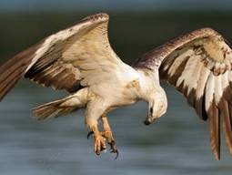  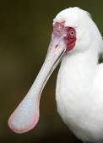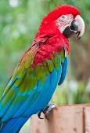  Eagles swoop down from a great height to catch live mice and other small animals for food.  Spoonbills sift through the mud for small insects and crabs to eat.  Parrots bite and tear at fruit. They also crack open seeds to get at the soft kernels inside.  Deduce from the information and photographs provided the adaptations these three birds have that enable them to access the food they eat. | Eagles have long, sharp talons that are strong enough to give them a firm grip on the live prey they capture.  The shape of the spoonbill’s beak acts as a scoop, sweeping through the water and picking up small creatures. Water and mud flows out from the side of the beak, leaving the food animals in the beak.  The long point of the parrot’s beak is ideal for tearing at fruit and tough fibres. The curved shape of the beak gives it extra strength so it can act like a nut cracker to open nuts and hard seeds. | 3
 | A type of bird called a cattle egret feeds on insects, especially grasshoppers, flies (adults and maggots) and moths. Cattle egrets are usually found with cattle and other large grazing and browsing animals. Scientific studies have shown that cattle egrets find more food when they are near a large animal than when feeding on their own. The cattle are not affected by the egrets in any way.  a Deduce the type of symbiotic relationship that exists between the cattle egret and the cattle.  b Justify your decision. | a Commensalism  b In a commensal relationship, one organism benefits and the other is not affected. In this relationship the cattle egret benefits by getting more food, and the cattle are unaffected. | 2
 | Compare the terms endangered, vulnerable and rare as they are used to describe species. | All three terms refer to species that are found in small numbers.  Endangered species are close to extinction and only very small numbers remain.  Vulnerable species have populations that are rapidly declining in numbers.  In rare species the populations are small but stable and are often spread over a wide area. | 3

Section C— Thinking scientifically (10 marks)

 | A biome is a large ecological region that has similar vegetation and climate. Use the map below to identify two biomes found in Australia.  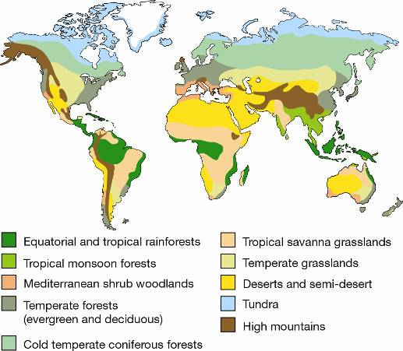  A Desert and high mountains  B Equatorial rainforest and cold temperate coniferous forest  C Temperate grassland and desert  D High mountains and tundra | C | 1
 | 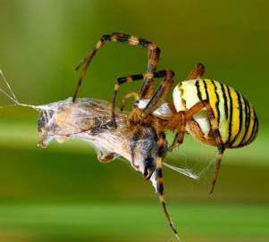  Deduce the relationship between the two animals in this photograph.  A Parasite/host  B Predator/prey  C Commensalism  D Mutualism | b | 1
 | 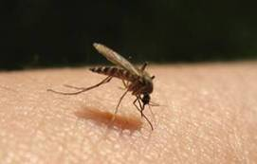  Deduce the relationship between the mosquito and the human whose arm can be seen in the photograph.  A Predator/prey  B Commensalism  C Mutualism  D Parasite/host | D | 1
 | Compare the three graphs to identify the relationships between sheep numbers, kangaroo numbers and rainfall.  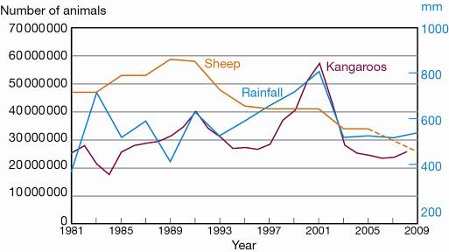  A The number of sheep and the number of kangaroos follow the same pattern.  B Sheep numbers are high when rainfall is good.  C Kangaroo numbers are higher in years of good rainfall.  D Rainfall does not affect sheep or kangaroo numbers. | C | 1
 | Interpret the food web then identify the organisms that are third-order consumers.  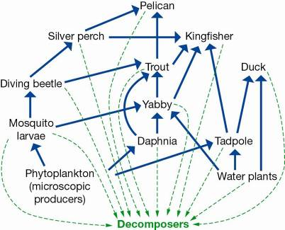  A Silver perch, trout, pelican  B Kingfisher, daphnia, trout  C Silver perch, tadpole, duck  D Pelican, duck, daphnia | A | 1
 | Identify the food chain that is part of this food web.  A Phytoplankton → daphnia → trout → duck → decomposers  B Water plant → tadpole → trout → kingfisher → decomposers  C Phytoplankton → mosquito larvae → yabby → silver perch → pelican → decomposers  D Water plant → yabby → trout → kingfisher → decomposers | D | 1
 | Identify the organism that is a second-, third- and fourth-order consumer at different times in the food web.  A Trout  B Pelican  C Silver perch  D Kingfisher | D | 1
 | Adelie penguins live in Antarctica where it is very cold all year round. They get all their food from the ocean and have to be able to swim fast to escape predators. Deduce which of the adaptations of penguins listed below is of least benefit to their survival in the Antarctic.  A They have short, stocky bodies that reduce the amount of heat that is lost.  B They catch and swallow their live prey whole.  C Their feathers are densely packed and along with oil from oil glands they provide a totally waterproof layer.  D The bones in the wings are fused and flattened to form strong paddle-like wings. | B | 1
 | 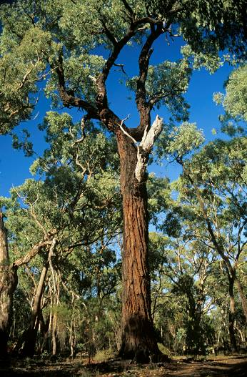  Fire is part of the environment in Australia. Ironbark trees such as the one in the photograph are adapted to fire. Select the characteristic of an ironbark tree that helps the tree to survive fire.  A The bark is very thick with deep furrows.  B The trees grow tall and straight.  C The wood is hard and very dense.  D The leaves produce large amounts of oil. | A | 1
 | The two photographs below are of part of a banksia tree showing the fruit that contains the seeds. The pictures show the tree before and after a fire. Deduce the effect of the fire.  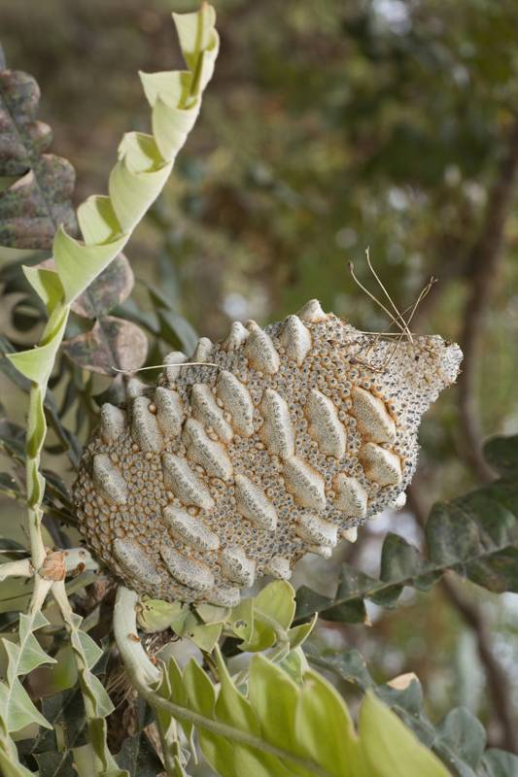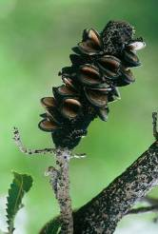  A The fire burns the tree and fruit, killing the tree and any seeds.  B The fruit explodes and the seeds are destroyed.  C The fire dries the fruit, which opens, allowing the seeds to come out.  D The fire just causes the tree and the fruit to turn black. | C | 1

